SCHALLER AUTOMATION is the specialist for oil mist detectors and protection systems for diesel and dual fuel engines.
We can answer all your requests, both commercial and technical.
We ensure:
• the supply of Oil Mist Detector VN 115/116/215 – 87plus, VN2020, VN301plus
• the supply of SCHALLER AUTOMATION spare parts
• the visit of detectors on-site or in our workshop
• The study, installation, commissioning of new systems and connections to process
• the retrofitting of obsolete installations

PRODUCTS

OIL MIST DETECTORS

VISATRON VN301plus VISATRON VN2020
Developed for diesel, gas and dual-fuel engines, the VN2020 can check up multiple measuring points simultaneously via an engine- specific mounting kit for complete monitoring of the crankcase.
An alarm is triggered if the oil mist concentration exceeds the alarm level at one of the measuring points. The VN2020 protects your engine preventively, permanently and reliably, contri-buting to the safety of operator and machine.
The VN301plus offers a range of impressive features.
The system consists of one Central Unit with up to 20 sensors (Master Slave Version).
Each sensor monitors one crankcase compartment (or other engine space) independently. The Central Unit provides the operator with necessary information on the system status.
Central Unit can communicate with modern control systems via CAN Bus. Flexible solution for any kind of engine.

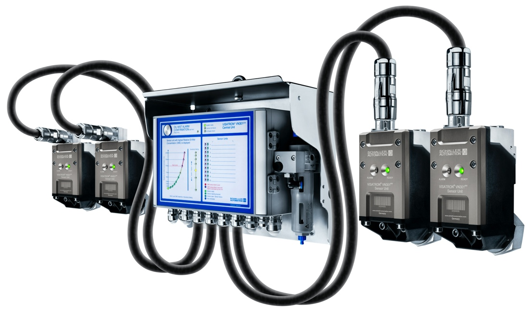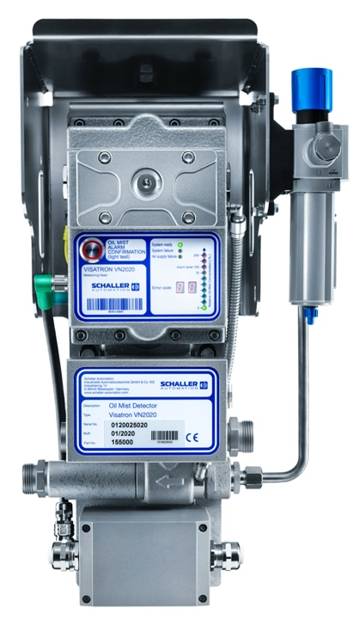
Click on the image to access the Leaflet
Click on the image to access the Leaflet

CONDITION MONITORING SYSTEM SSYSTEMSYSTEMOIL MIST DETECTORS

ACCOMOS BEAROMOS®2020
The BEAROMOS®2020 slide bearing monitoring system is a new way of detecting the first metal- to-metal contact when bearing damage occurs.
Protect your crankshaft simply and cost- efficient! One sensor per engine is enough to monitor the main bearings.
The ACCOMOS - an innovative 3-axis acceleration monitoring system developed for both, a quick detection of vibration deviation from normal and to verify the engine to be within the limits of DIN ISO 10816-6.
Permanently installed within minutes.

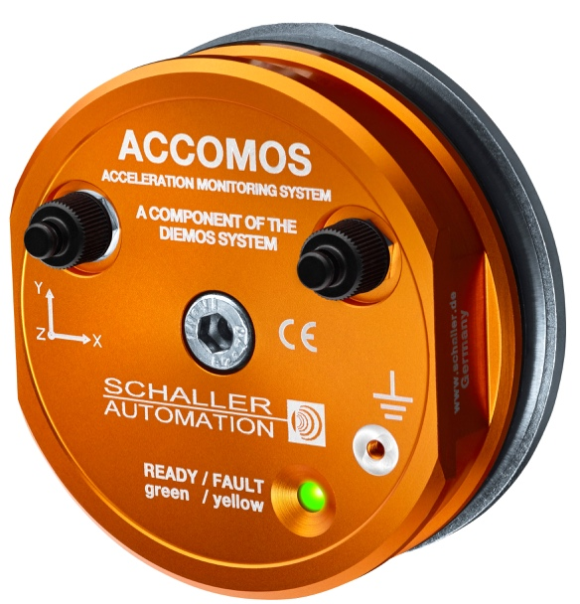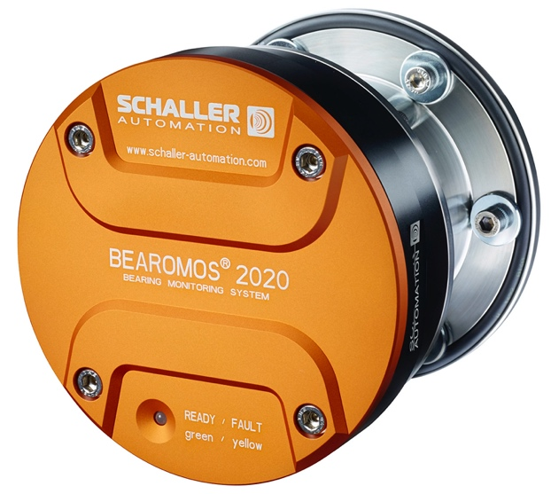
Click on the image to access the Leaflet
Click on the image to access the Leaflet

